**Running TROVE from Eclipse Java**

Eclipse version:

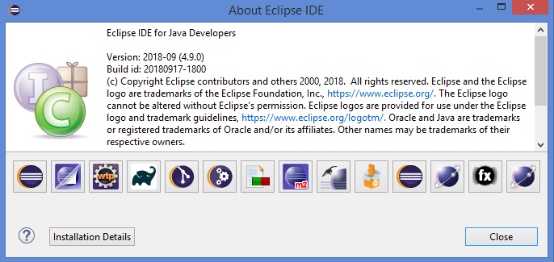

Setup:

The JARs can be found in the JARs folder in TROVE github

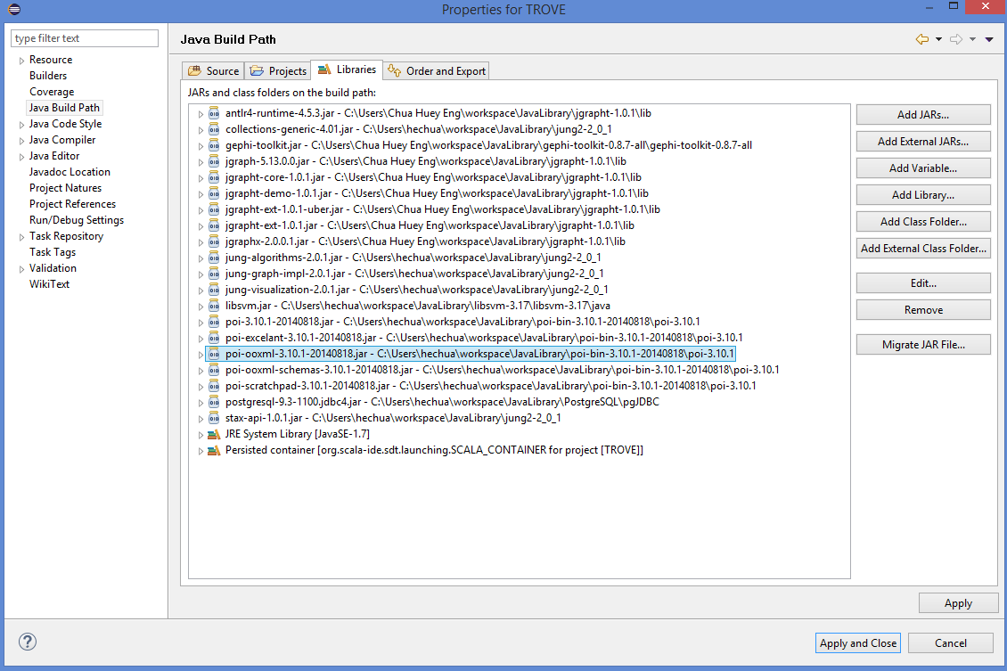

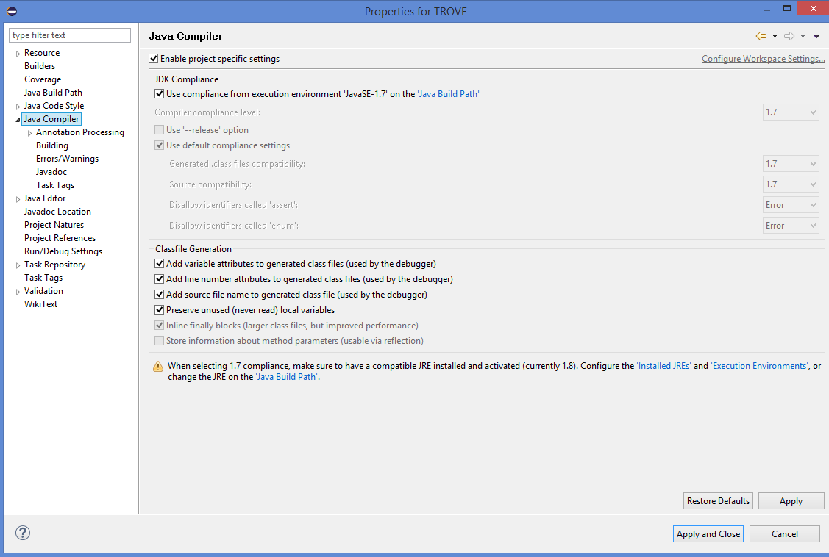

Run TROVE using Eclipse:

Select TROVE.java and click the run button (green round icon with a white arrow)

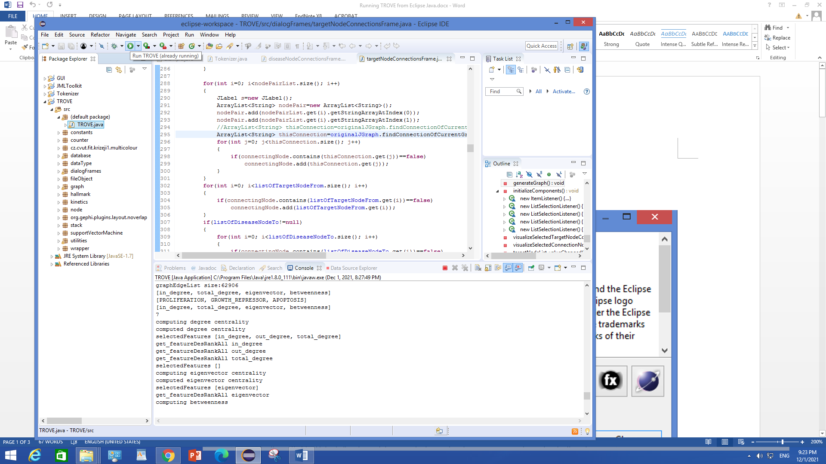

For first run,

* go to File -> Open Human Signaling Network File (This can take about 5-10 minutes)
* once completed, go to File -> Open Network Annotation File
* if data are loaded properly, you should see the following when you go to Action -> Visualize Preloaded Network.

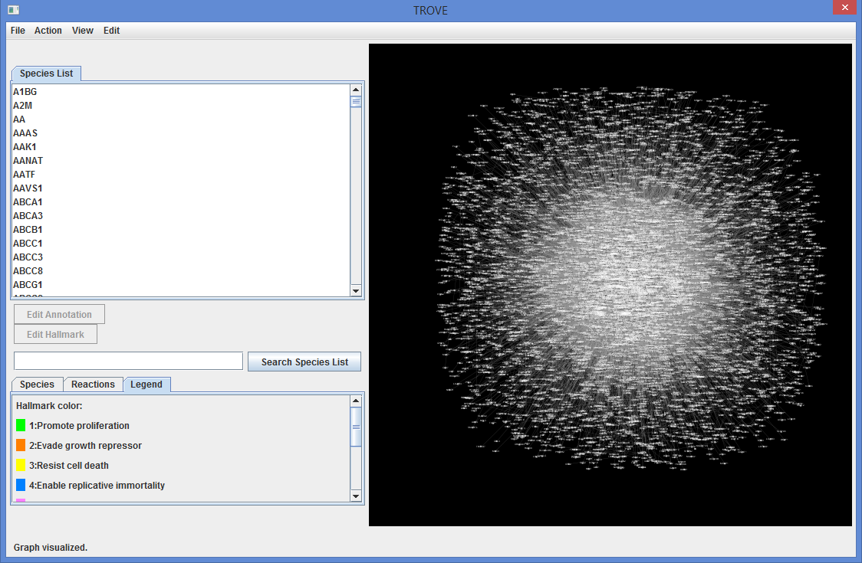

When you select View -> View Hallmark, you should see the following:

